NAME; simma Mahesh

Id: ACTE2415

ROLE:Junior Software Engineer

JIRA project Managemeent

Create User Stories & Issues, Plan Sprints, & Distribute Tasks Across Your **Software** Team

A user story is an informal, general explanation of a software feature written from the perspective of the end user or customer.

Bug − A problem that impairs or prevents the functions of the product

 Epic − A big user story that needs to be broken down. Created by JIRA Software - do not edit or delete. Improvement − An improvement or enhancement to an existing feature or task.

DETAIL ABOUT JIRA PROJECT MANAGEMENT TOOL

.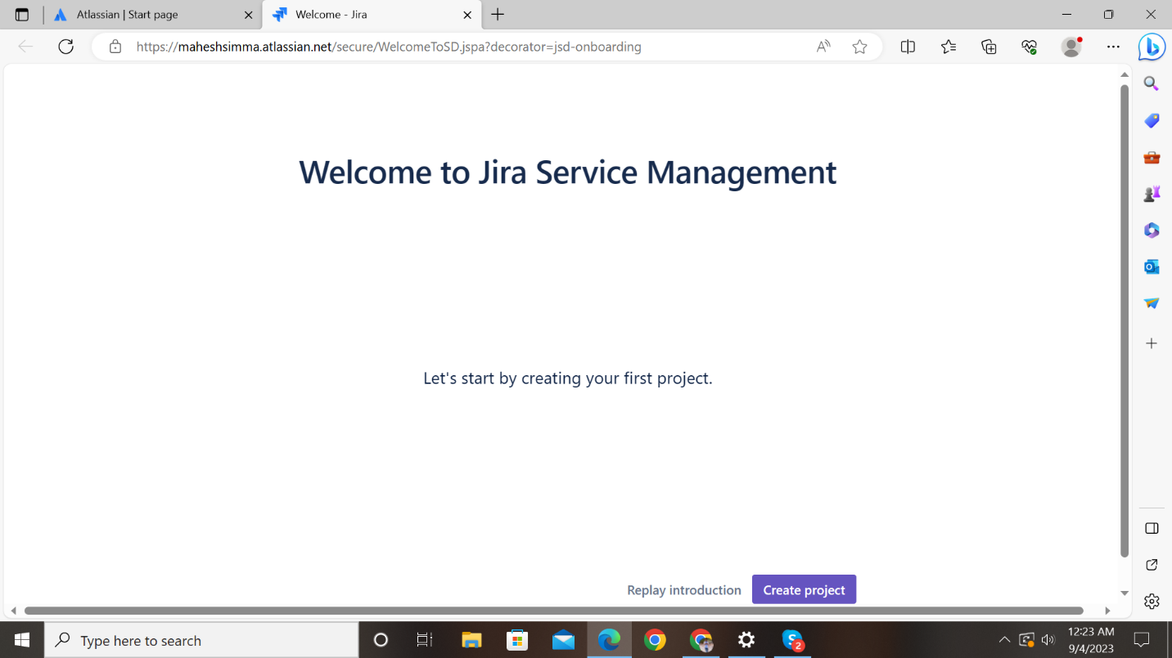

This is the first phase of jira ser vciee management

In this phase we assign a project name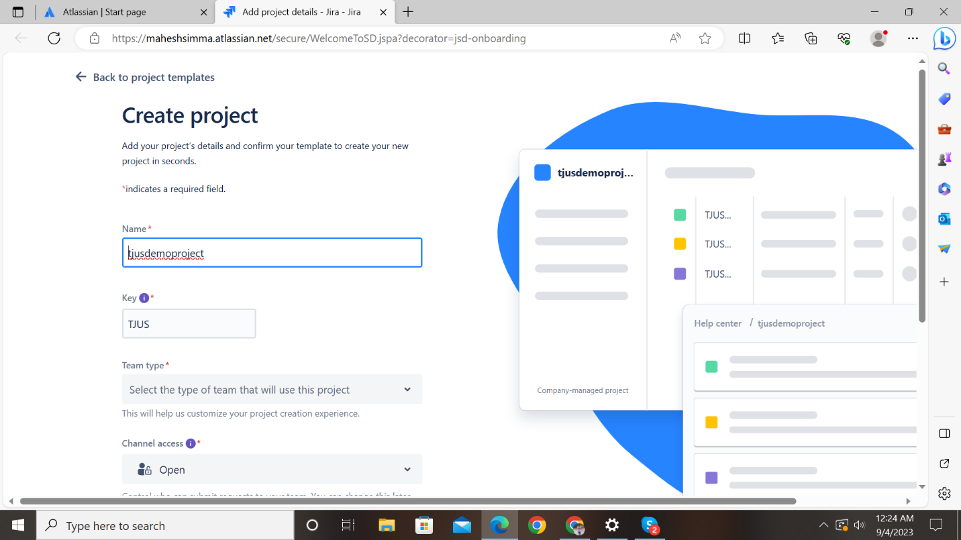

in this we select project template as scrum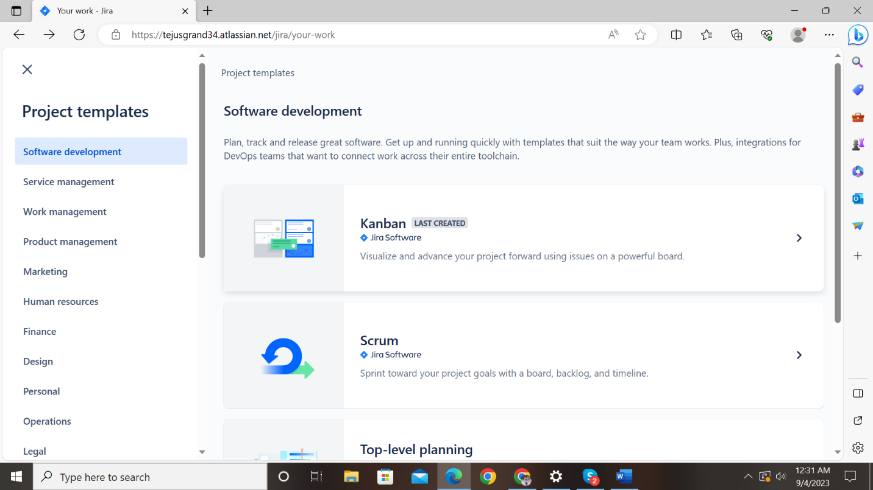

in this module we select use template

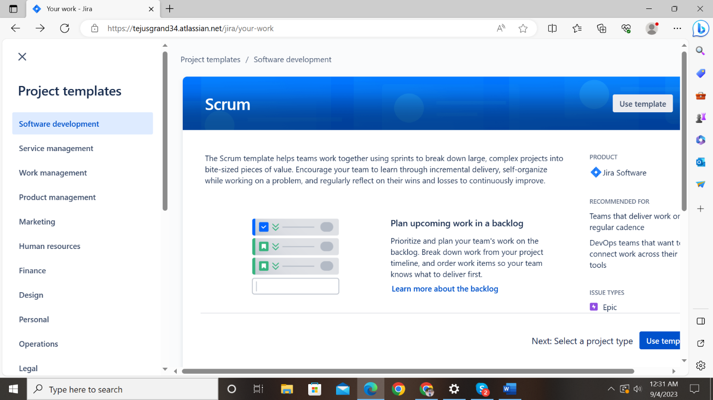

In this phase we select the team-managed project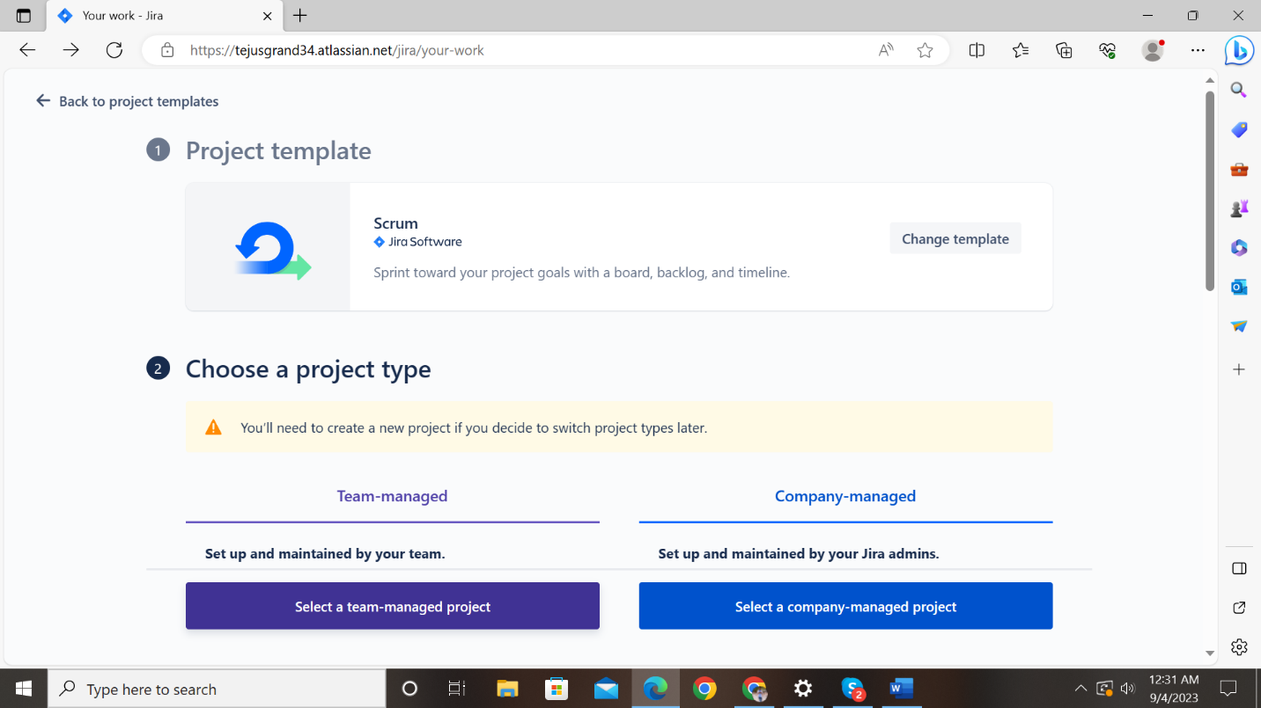

In this phase we add project details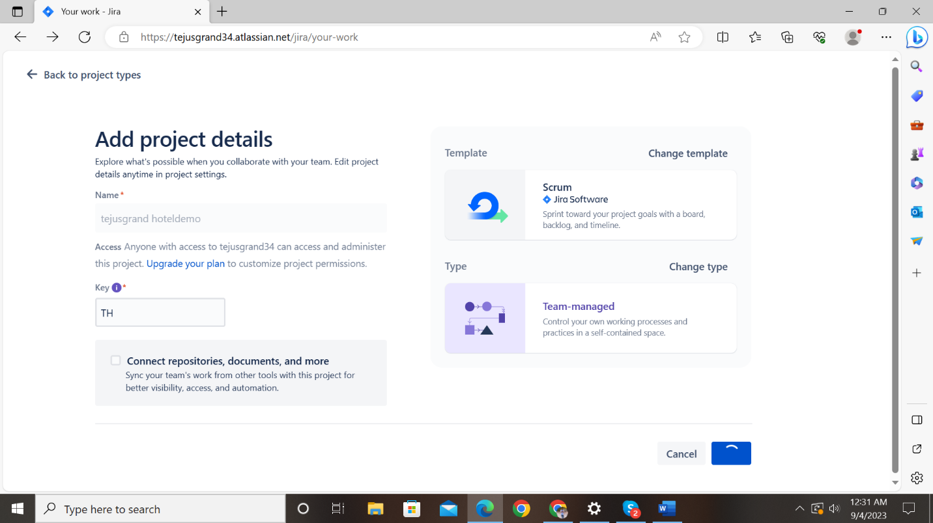

In this phase we click on goto project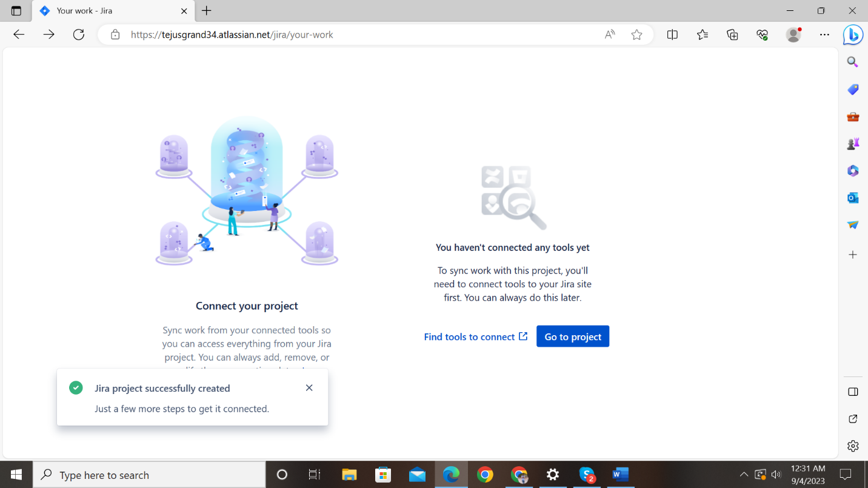

In this phase we click on backlog option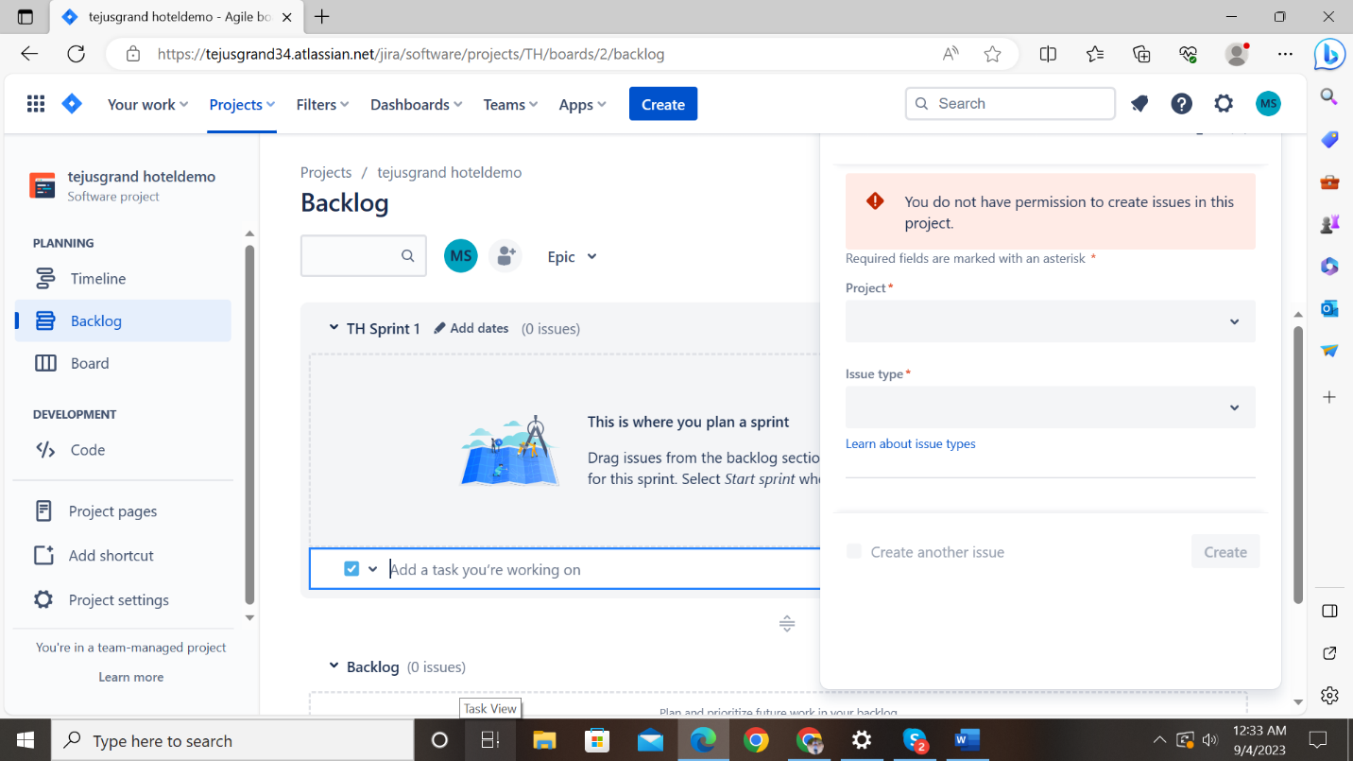

In this phase we create stories and we create one backup story also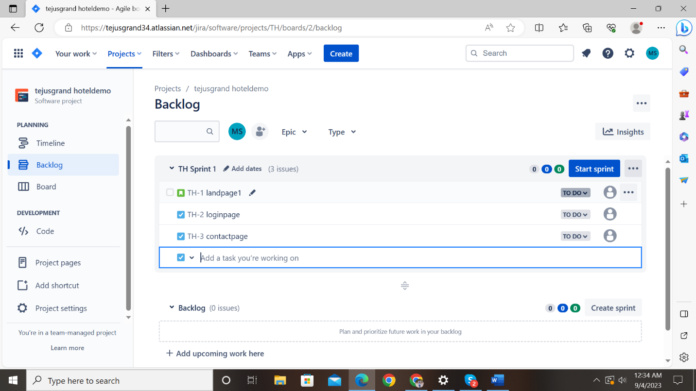

After creation of user stories we have edit work flow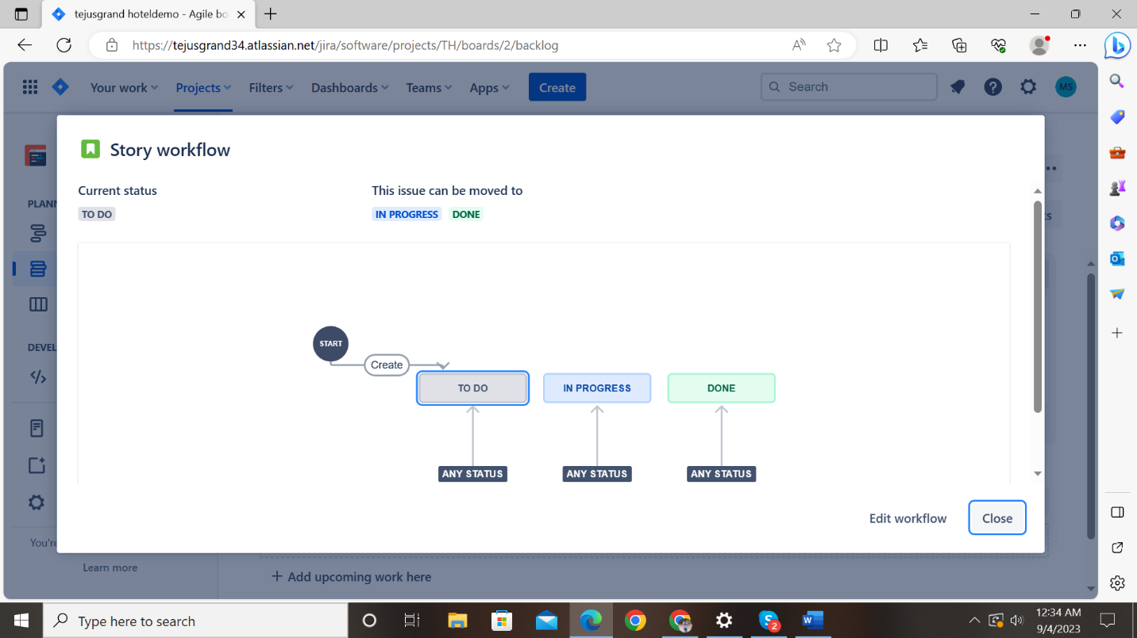

In this phase we add a testing to the work flow and update the work flow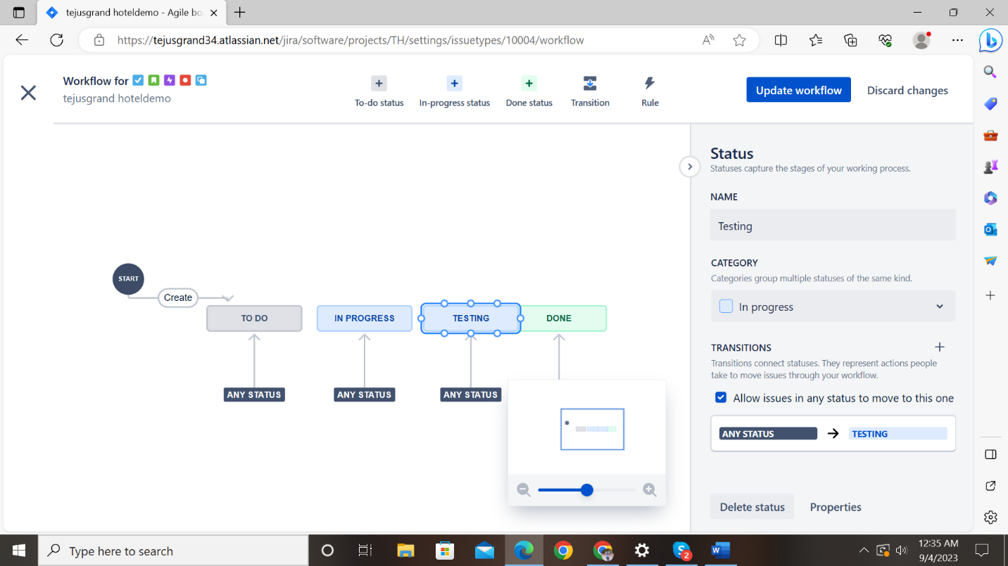

In this phase we update the work flow after click on save and continue

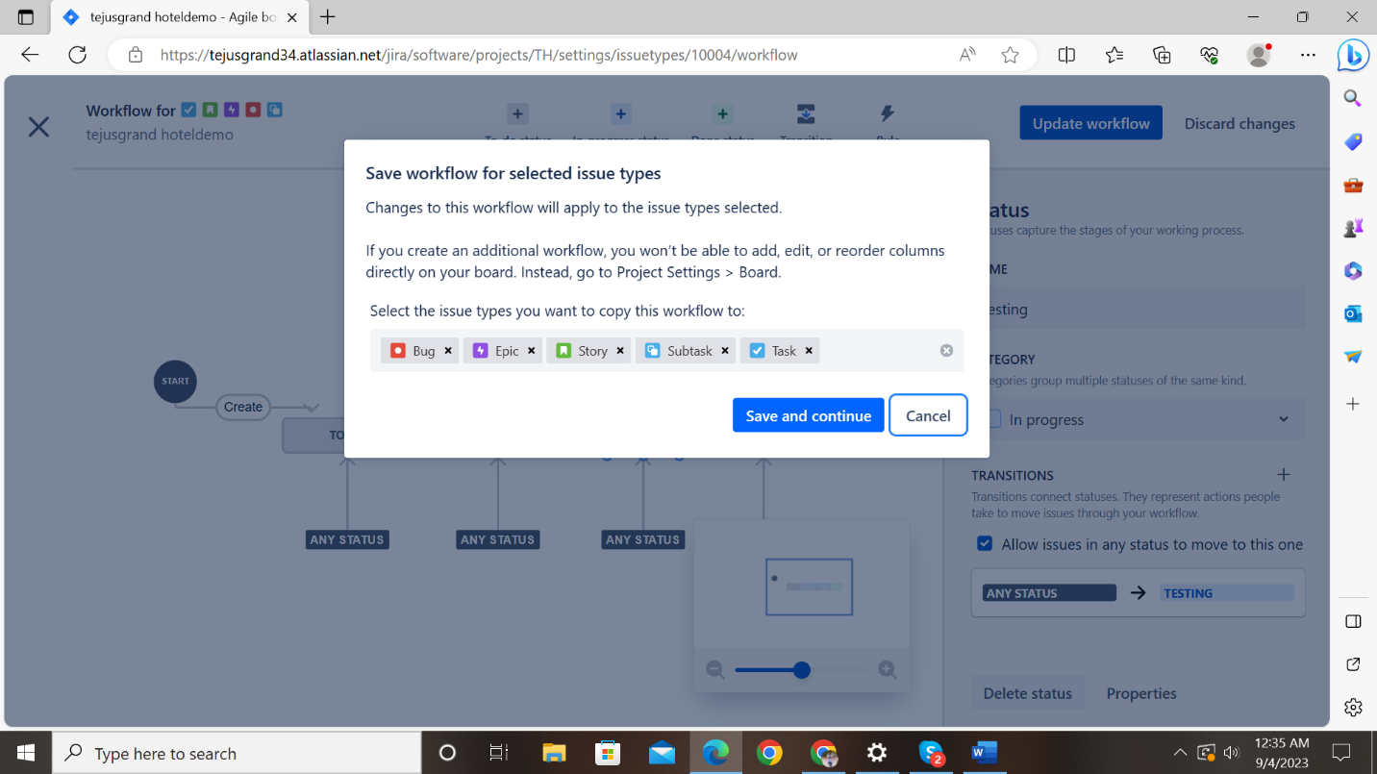

In this phyase we see we see work flow status

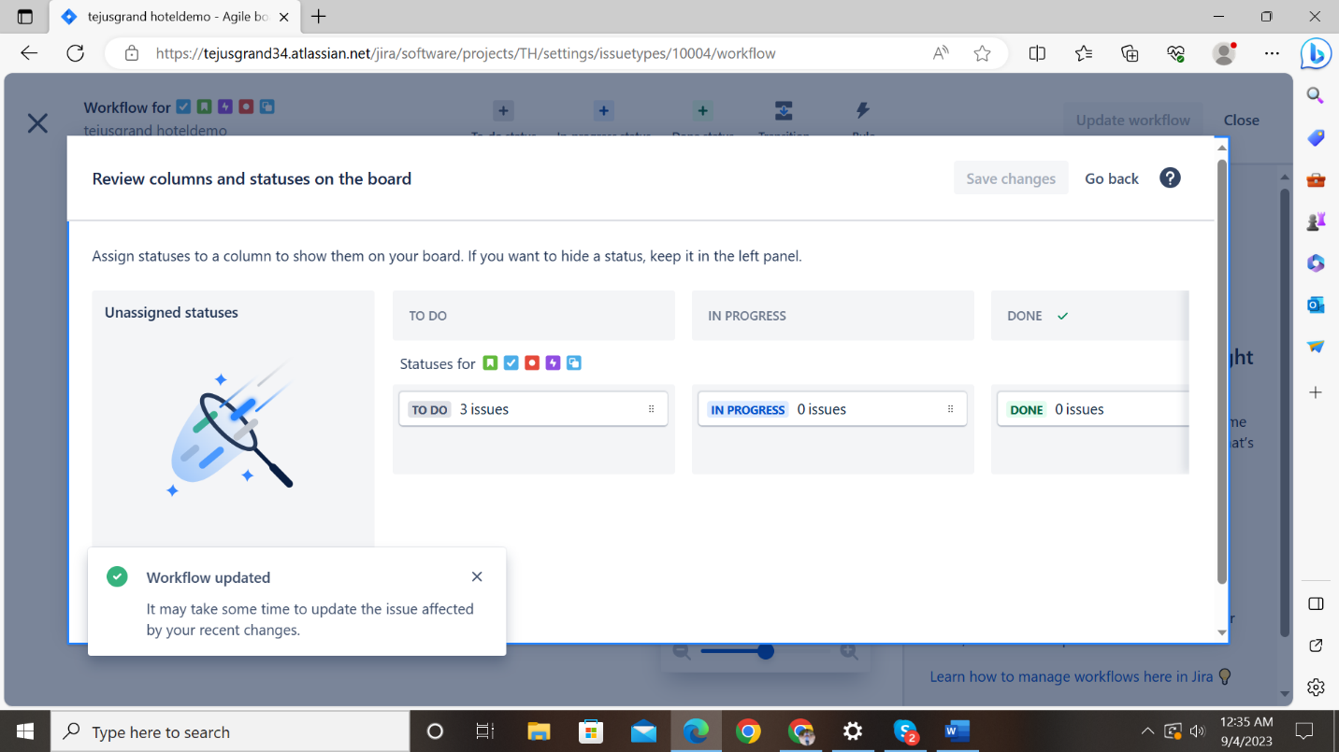

In this phas e we assign user stories to team mates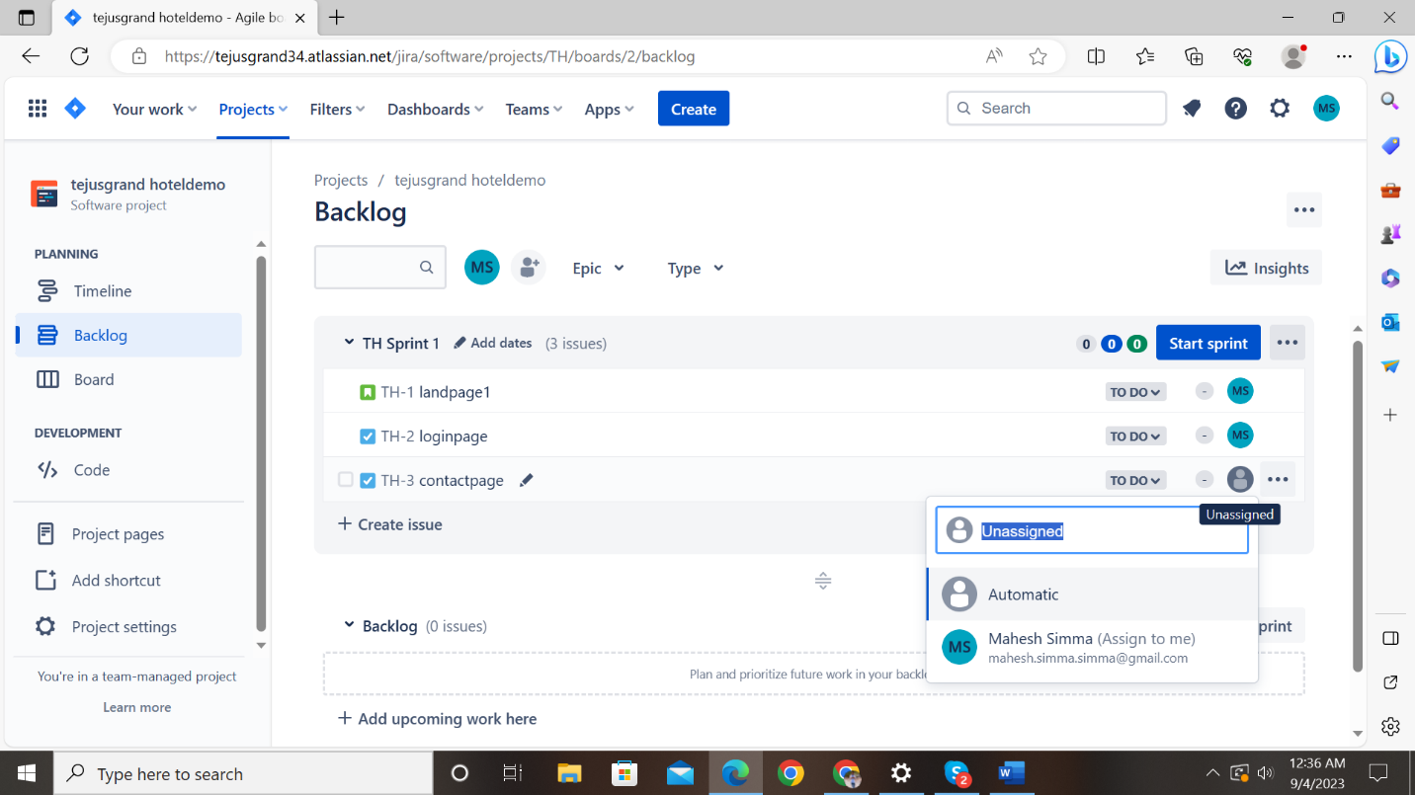

In this phase we strat the print and sprint time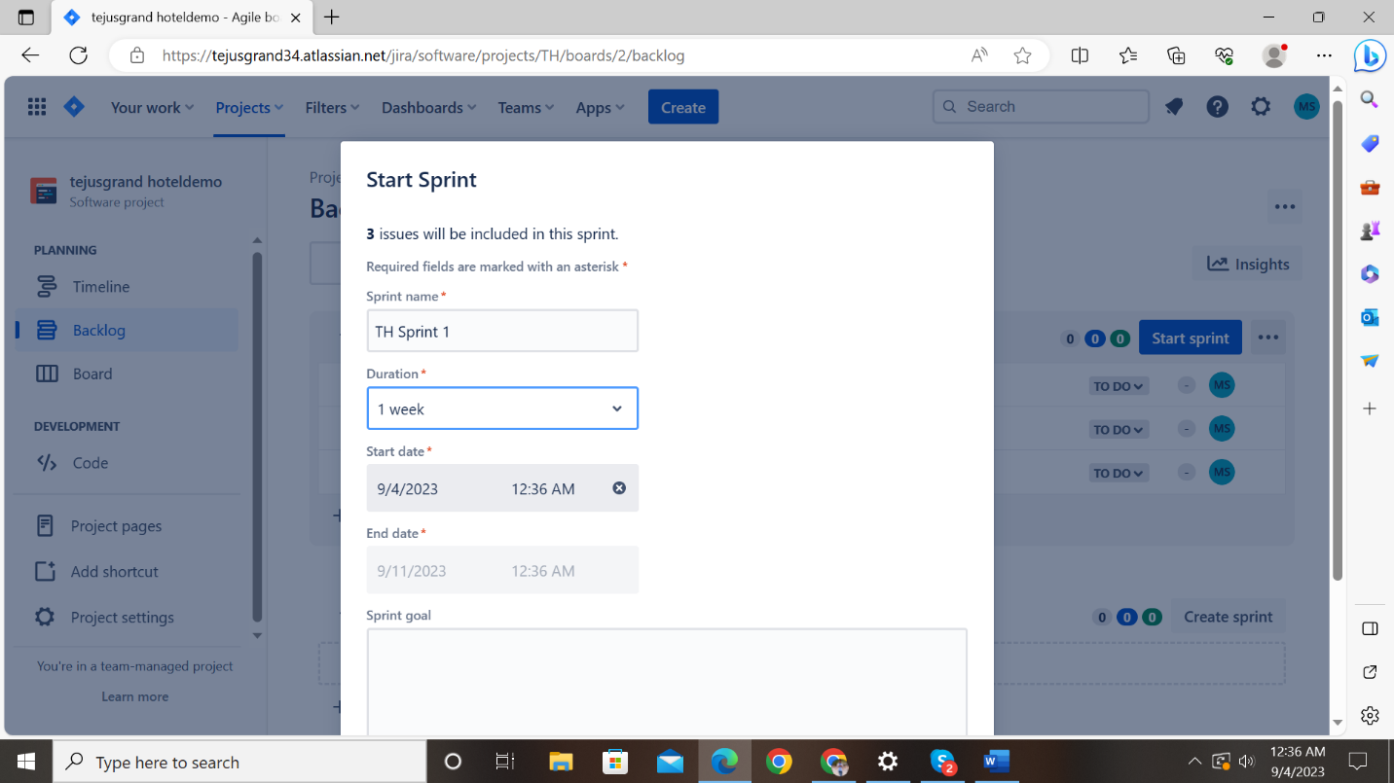

In this phase we saw the work flow status with stories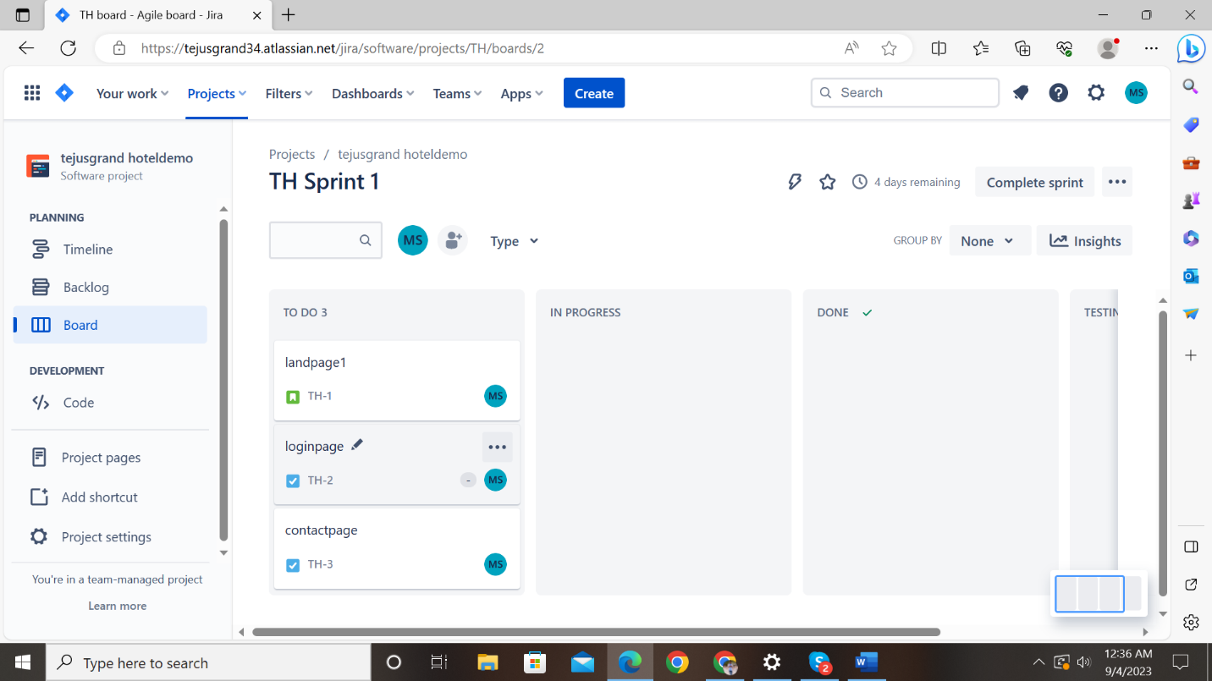

In this phase we move the stories to testing and done 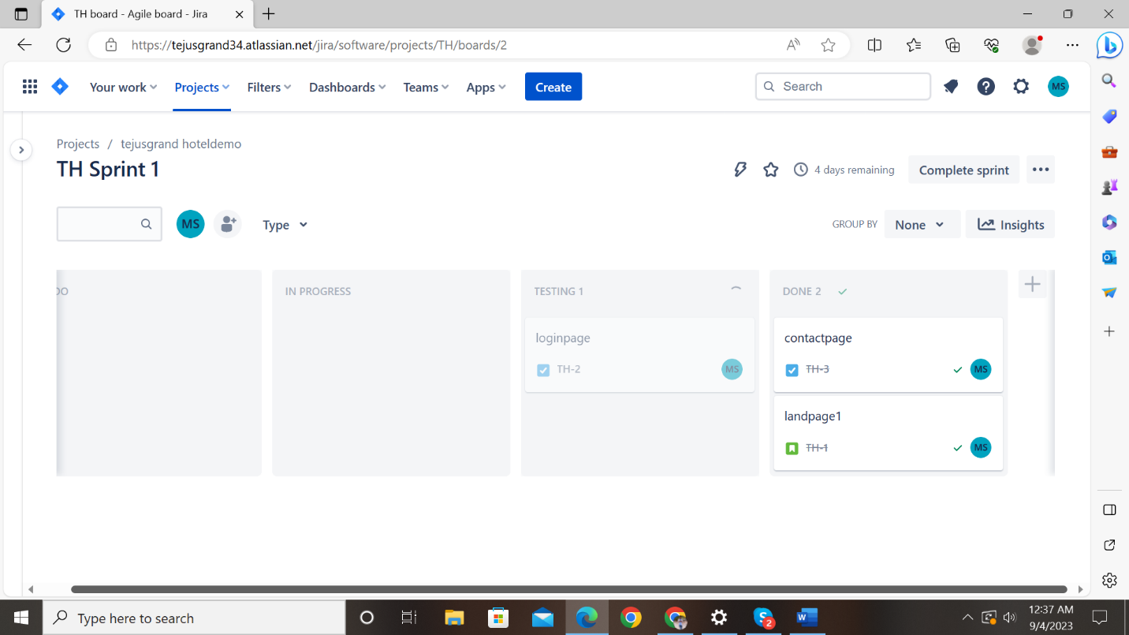

In this phase we see the result as 2 completed issues and open issue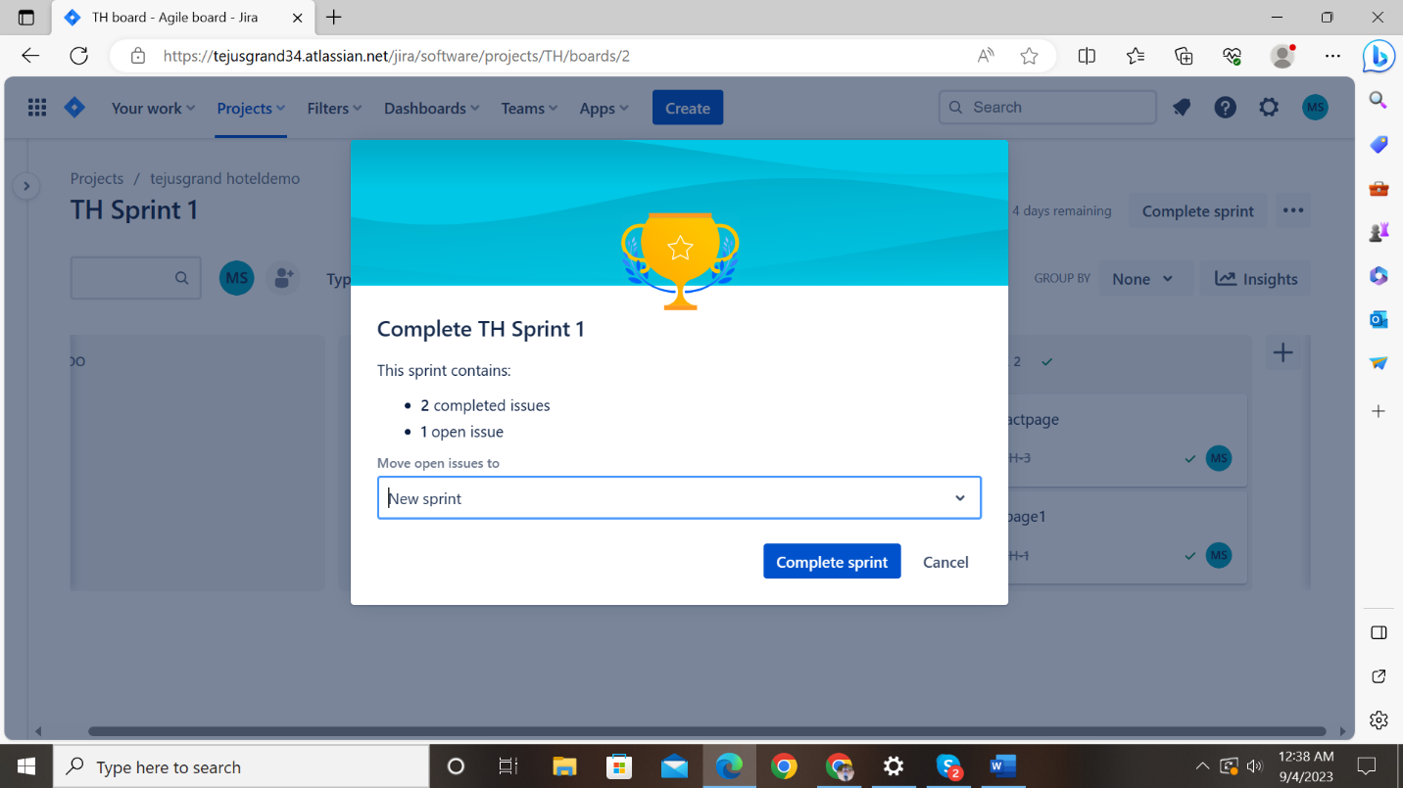

Finally we complete the sprint

